**59.2. Spring REST - Retrieve POJOs as JSON- Development Process**

**Development Process (Step-by-Step)**:

* Create Java POJO class for Student
* Create Spring REST Service using **@RestController**

**Step 1: Create Java POJO class for Student**:

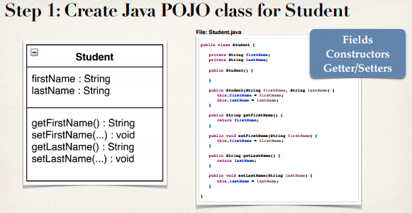

**Student.java class**:

**package** com.ruhul.springdemo.entity;

**public** **class** Student {

**private** String firstName;

**private** String laseName;

**public** Student() {

}

**public** Student(String firstName, String laseName) {

**this**.firstName = firstName;

**this**.laseName = laseName;

}

**public** String getFirstName() {

**return** firstName;

}

**public** **void** setFirstName(String firstName) {

**this**.firstName = firstName;

}

**public** String getLaseName() {

**return** laseName;

}

**public** **void** setLaseName(String laseName) {

**this**.laseName = laseName;

}

}

**Step 2: Create @RestController**:

**package** com.ruhul.springdemo.rest;

**import** java.util.ArrayList;

**import** java.util.List;

**import** org.springframework.web.bind.annotation.GetMapping;

**import** org.springframework.web.bind.annotation.RequestMapping;

**import** org.springframework.web.bind.annotation.RestController;

**import** com.ruhul.springdemo.entity.Student;

@RestController

@RequestMapping("/api")

**public** **class** StudentRestController {

// define endpoint for "/students" => return list of students

@GetMapping("/students")

**public** List<Student> getStudents() {

List<Student> theStudents = **new** ArrayList<>();

theStudents.add(**new** Student("Ruhul", "Amin"));

theStudents.add(**new** Student("Rezau", "Islam"));

theStudents.add(**new** Student("Osman", "Goni"));

theStudents.add(**new** Student("Kapil", "Dev"));

theStudents.add(**new** Student("Mezbaul", "Islam"));

**return** theStudents;

}

}

59.2. Spring REST - Retrieve POJOs as JSON- Development Process